|  |  |
| --- | --- |
|  |  |



**FPT ACADEMY INTERNATIONAL FPT – APTECH COMPUTER EDUCATION**

**A1 UNIFORMS EPROJECT-SEMESTER 1**

|  |  |  |  |
| --- | --- | --- | --- |
| Center Name | | ACE-HCMC-2-FPT  Address: 590 Cach Mang Thang Tam, District 3, Ho Chi Minh City | |
| Instructor | | Mr. Nguyen Ngo Phuoc | |
| Class | | T1.2005.E1 | |
| Group | | 3 | |
| Group members | | **Name** | **Student ID** |
| TRAN VU LINH | Student1268266 |
| VU HOANG THACH | Student1248880 |
| NGUYEN NGOC THIEN NGAN | Student1262864 |
| HA TAN PHAT | Student1248886 |
| Duration | **Start**  **date** | 29th July 2020 | |
| **End**  **date** | 01st August 2020 | |

**THIS IS TO CERTIFY THAT**

**MR./MS.:**

TRAN VU LINH

VU HOANG THACH

NGUYEN NGOC THIEN NGAN

HA TAN PHAT

**HAS SUCCESSFULLY DESIGNED & DEVELOPED**

eProject: A1 UNIFORMS

**Submitted by:** TRAN VU LINH

**Date of issue:** July 29th 2020

**Authorized Signature**

Contents

ACKNOWLEDGEMENT 4

SYNOPSIS 4

REQUIREMENT SPECIFICATION 5

HARDWARE/ SOFTWARE REQUIREMENTS 6

SCOPE OF THE WORK (Summary) 7

ARCHITECTURE AND DESIGN OF THE SYSTEM 8

E-COMMERCE CONTEXT LEVEL DIAGRAM 9

DIAGRAM OF THE WEBSITE 10

TASK SHEET REVIEW 1 11

SITE MAP 12

GENARAL SIMULATION OF THE WEBSITE 13

1. Home Page 13

2. Product 14

3. product detail 15

4. View Cart 16

5. Check Out 17

6. Contact 18

7. About 19

8. Feedback 20

TASK SHEET REVIEW 2 21

WEBSITE DESCRIPTION 22

MODULE DESCRIPTION 31

TASK SHEET REVIEW 3 43

### ACKNOWLEDGEMENT

First of all, we are thankful to Mr. Nguyen Ngo Phuoc for supporting us on the project and the cooperation of each team’s member. The project couldn’t be finished without their hard work. The project help us get more experience in team working and problem solving. It gives us a lot of confidence to face an interview as us have worked on a project.

Finally, we express our gratitude toward our families and colleagues for their kind cooperation and encouragement which help us in completion of this project.

### SYNOPSIS

A1 uniforms was founded in 2016 and since then they have been one of the leading **Uniform Manufacturers in the country.** they supply many schools in country and they give them the best uniforms. They supply affordable school uniforms for girls and boys. When clients come, they cater to client’s vision. As a team of professionals they understand what clients want and deliver the best results.

At A-1 uniform designs are innovative and there are always fresh and new ideas for each and every client. The textiles are of excellent quality and they make each uniform according to the size requirements given. The fit is ingenious and they provide with the best. A-1 Uniform is a part of a continuous strategic process of creative inputs from experts in the field. They consider each client differently and ensure the satisfaction with the end results. Each client is given the uttermost importance.

The entire team works together to achieve the same goal.

### REQUIREMENT SPECIFICATION

Looking at the demands and increasing power of web, the management of A-1 are looking for hosting a website of their products which will be easier to reach to them.

You are being approached for developing the site “A1uniforms.com”

The Web site is to be created based on the following requirements.

* + 1. The home page must describe the keywords or highlight of the shop along with all navigation link defined.
    2. Products should be categorized as
       1. Shirts
       2. Skirts
       3. Frocks
       4. P.T. T-shirts
       5. P.T. shorts
       6. P.T. track pants
       7. Belts
       8. Ties
       9. Logos
       10. Socks
    3. The “Contact Us” page should have the Address of the Company and the mail address which when clicked will invoke the local mail client from where they can send an email. Address of the Company should be displayed using GeoLocation API (e.g. GoogleMaps).
    4. Contact Us page should also include the address and contact details of various outlets of A-1 uniforms in the city.
    5. About us page
    6. Feedback
    7. Navigation must be smooth.
    8. Color combination must be uniform throughout the project.

### HARDWARE/ SOFTWARE REQUIREMENTS

**For webmaster Hardware**

* 1 gigahertz (GHz) or faster compatible processor or System on a Chip (SoC)
* 1 gigabyte (GB) for 32-bit or 2 GB for 64-bit

**Software**

* Windows 7 OS or higher
* Sublime Text 3, Visual Studio Code
* Bootstrap 3, jQuery.
* HTML5 and Javascript supporting web browsers such as Edge, Chrome, Firefox, Opera…

**For web users Hardware**

* 1 gigahertz (GHz) or faster compatible processor or System on a Chip (SoC)
* 1 gigabyte (GB) for 32-bit or 2 GB for 64-bit

**Software**

* Windows 7 OS or higher
* HTML5 and Javascript supporting web browsers such as Edge, Chrome, Firefox,

Opera… *(Website best running on Edge browser).*

### SCOPE OF THE WORK (Summary)

**After discussing, our group has decided to create a Website follow the below contents:**

1. **Homepage:** Describe the keywords or highlight of the shop based on all navigation link defined. We have best seller, new arrival and trendy products toward to users. Moreover, we have a part for users subscribe to newsletter.
2. **Products:** For the user’s convenience, we display all of products on the navigation bar.
3. **Contact Us:** Display an address, phone number, fax and an email to contact with us. Besides, we have a form which users can fill some information as an email or a message for us. The address was displayed by using GeoLocation API (e.g. Google Maps).
4. **About:** Not only introducting about the main information, history and some factory’s image, but also presenting 4 members and a short video recording a process of project.
5. **Feedback:** Get the feedback from users.

### ARCHITECTURE AND DESIGN OF THE SYSTEM

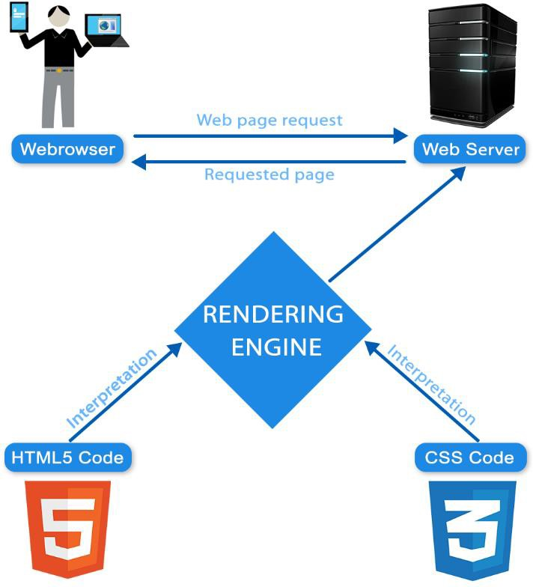

### E-COMMERCE CONTEXT LEVEL DIAGRAM

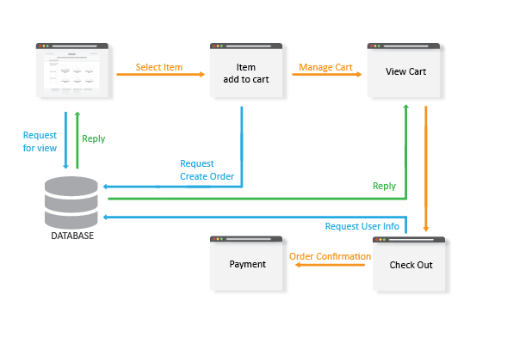

### DIAGRAM OF THE WEBSITE

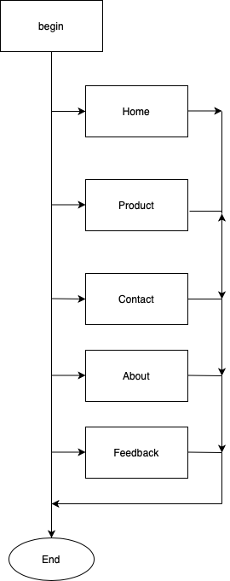

### TASK SHEET REVIEW 1

|  |  |  |  |  |  |  |  |
| --- | --- | --- | --- | --- | --- | --- | --- |
| **Project Ref. No.:**  **eP/Advertisement Portal Management System/01** | | **Project Title:** | **Activity Plan Prepared By:** | **Date of Preparation of Activity Plan:** | | | |
| **Sr.**  **No.** | **Task** | **Actual Start Date** | **Actual Days** | **Team Mate Names** | **Status** |
| 1 | Problem Statement | A1  Uniforms | Linh | 30/7/2020 | 1 | Linh | Completed |
| 2 | Analysis of A1Uniforms requirements about the website | 30/7/2020 | 1 | Ngan | Completed |
| 3 | The scope of the work (in brief) | 31/7/2020 | 1 | Phat | Completed |
| 4 | Architecture and design of the system | 31/7/2020 | 1 | Ngan | Completed |
| **5** | E-commerce Context Level Diagram | 31/7/2020 | 1 | Linh | Completed |
| 6 | Diagram of the website | 31/7/2020 | 1 | Thach | Completed |
| 7 | Task Sheet | 31/7/2020 | 1 | Phat | Completed |
|  | | | | | | | |
| **Date:** | | | | | | | |
| Signature of Instructor:  **Mr. Nguyen Ngo Phuoc** | | | | Signature of Team Leader:  **Tran Vu Linh** | | | |

### SITE MAP

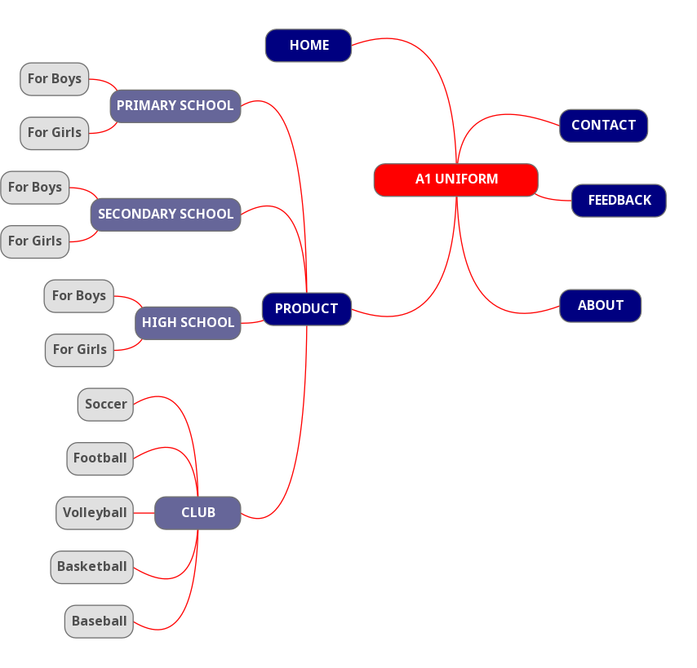

### GENARAL SIMULATION OF THE WEBSITE

#### Home Page

#### Product

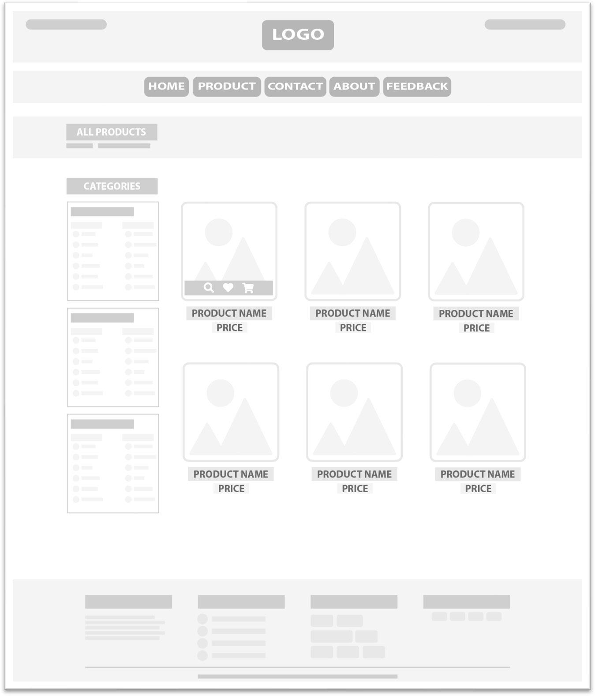

#### product detail

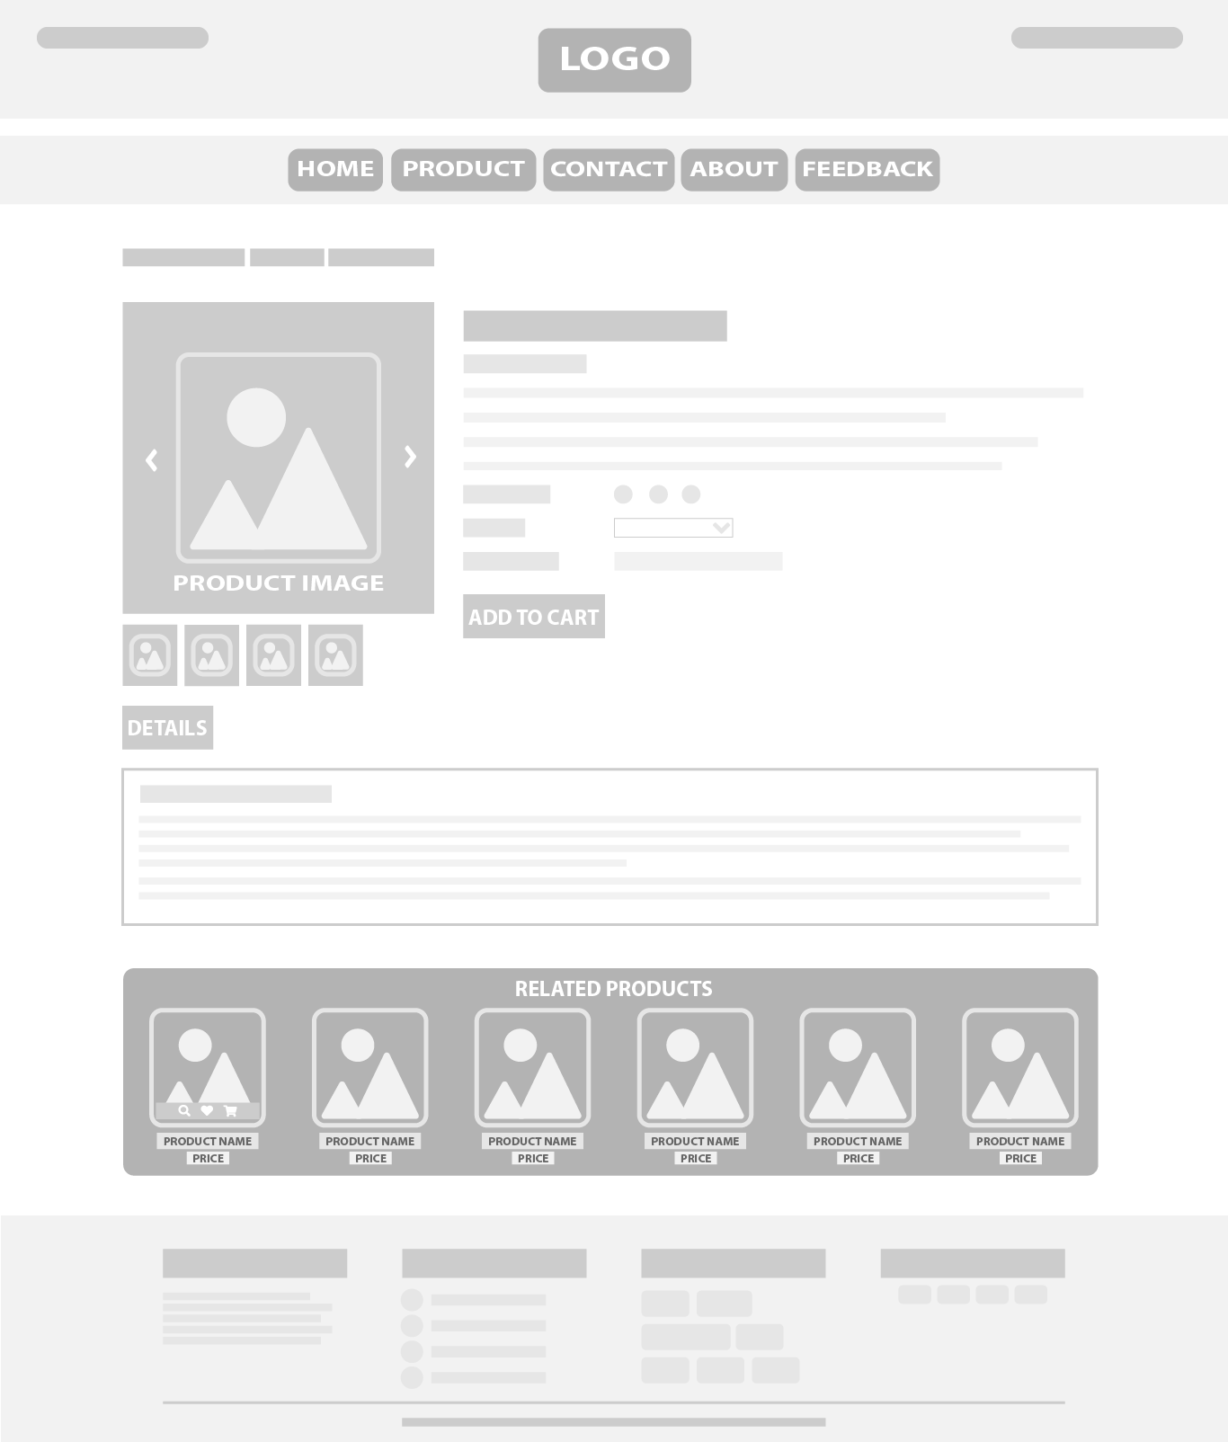

#### View Cart

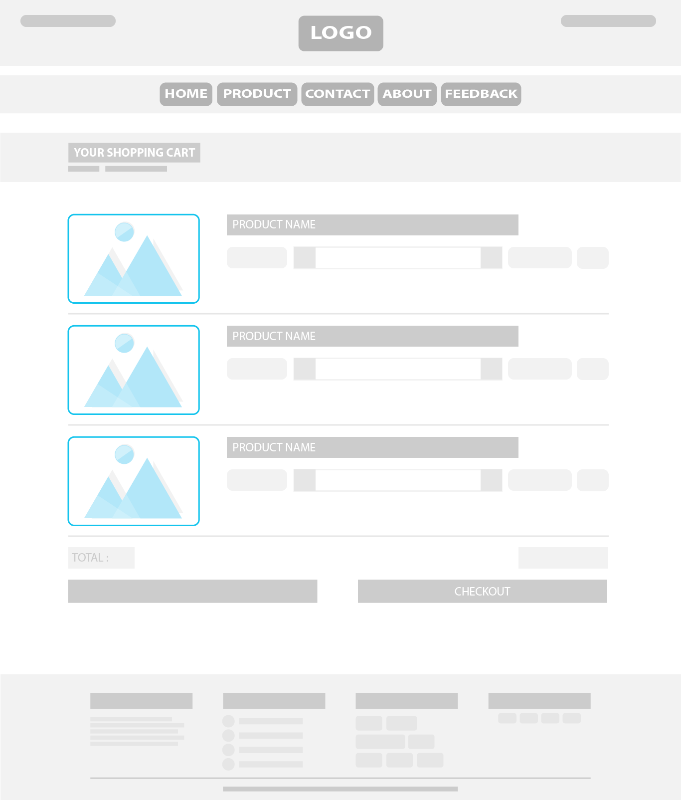

#### Check Out

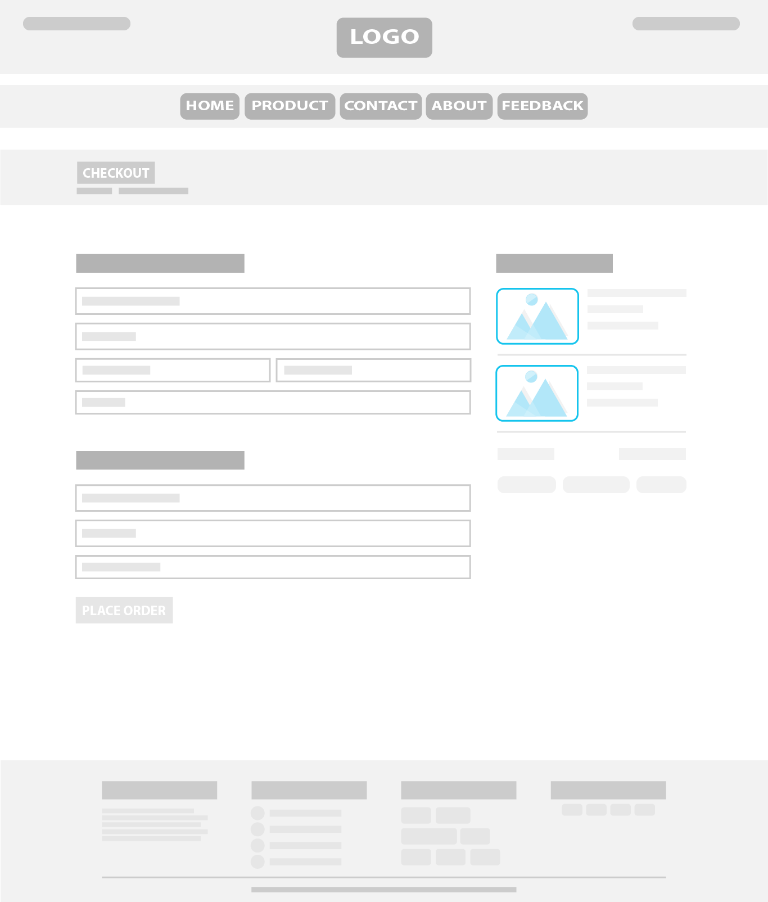

#### Contact

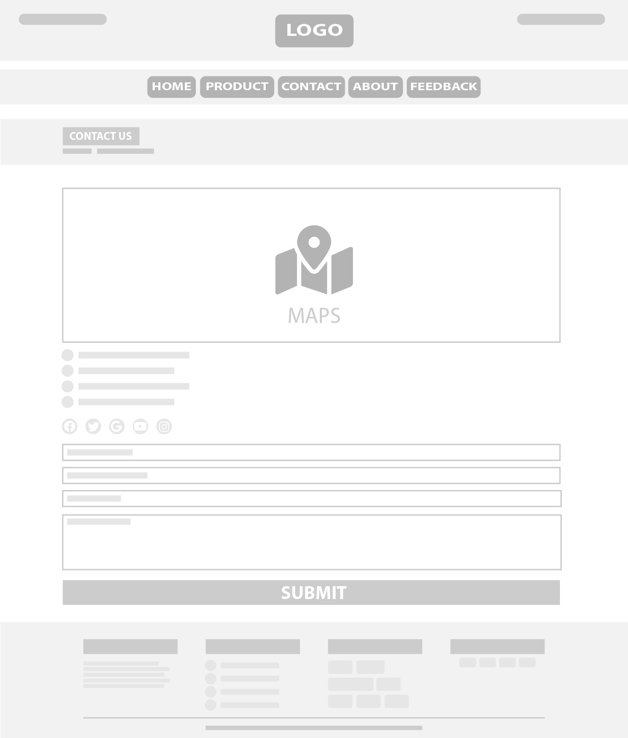

#### About

#### Feedback

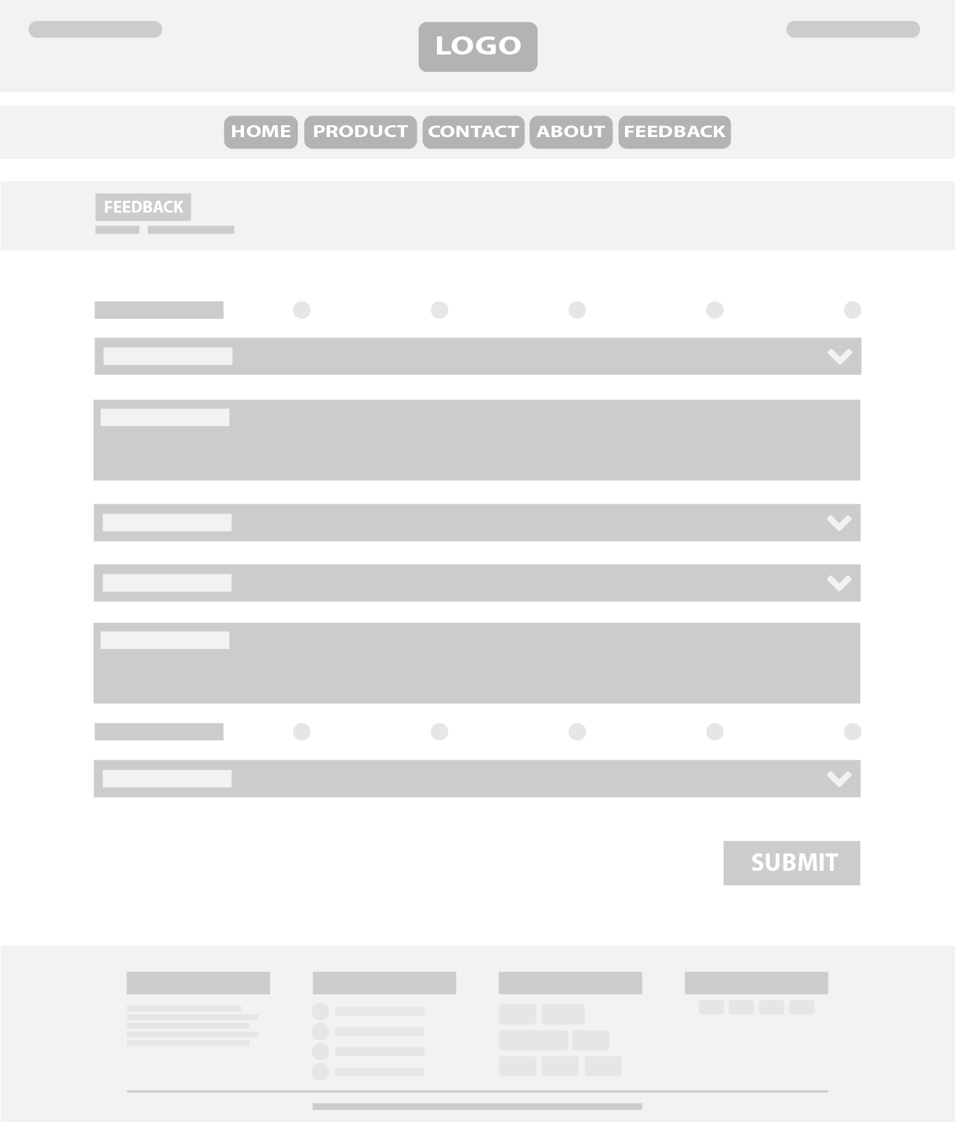

|  |  |  |  |  |  |  |  |
| --- | --- | --- | --- | --- | --- | --- | --- |
| **Project Ref. No.:**  **eP/Advertisement Portal Management System/01** | | **Project Title:** | **Activity Plan Prepared By:** | **Date of Preparation of Activity Plan:** | | | |
| **Sr.**  **No.** | **Task** | **Actual Start Date** | **Actual Days** | **Team Mate Names** | **Status** |
| 1 | Site Map | A1  Uniforms | Linh | 11/8/2020 | 1 | Ngan | Completed |
| 2 | General Simulation of Website | 11/8/2020 | 1 | Linh | Completed |
| 3 | Task Sheet | 11/8/2020 | 1 | Phat | Completed |
|  | | | | | | | |
| **Date:** | | | | | | | |
| Signature of Instructor:  **Mr. Nguyen Ngo Phuoc** | | | | Signature of Team Leader:  **Tran Vu Linh** | | | |

### TASK SHEET REVIEW 2

### WEBSITE DESCRIPTION

1. **Homepage**

Introduction best seller, new arrival and trendy products suitable for users. Furthermore, we have a part for users subscribe to newsletter.

**On pc On Smartphone**

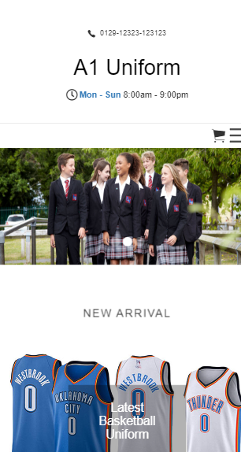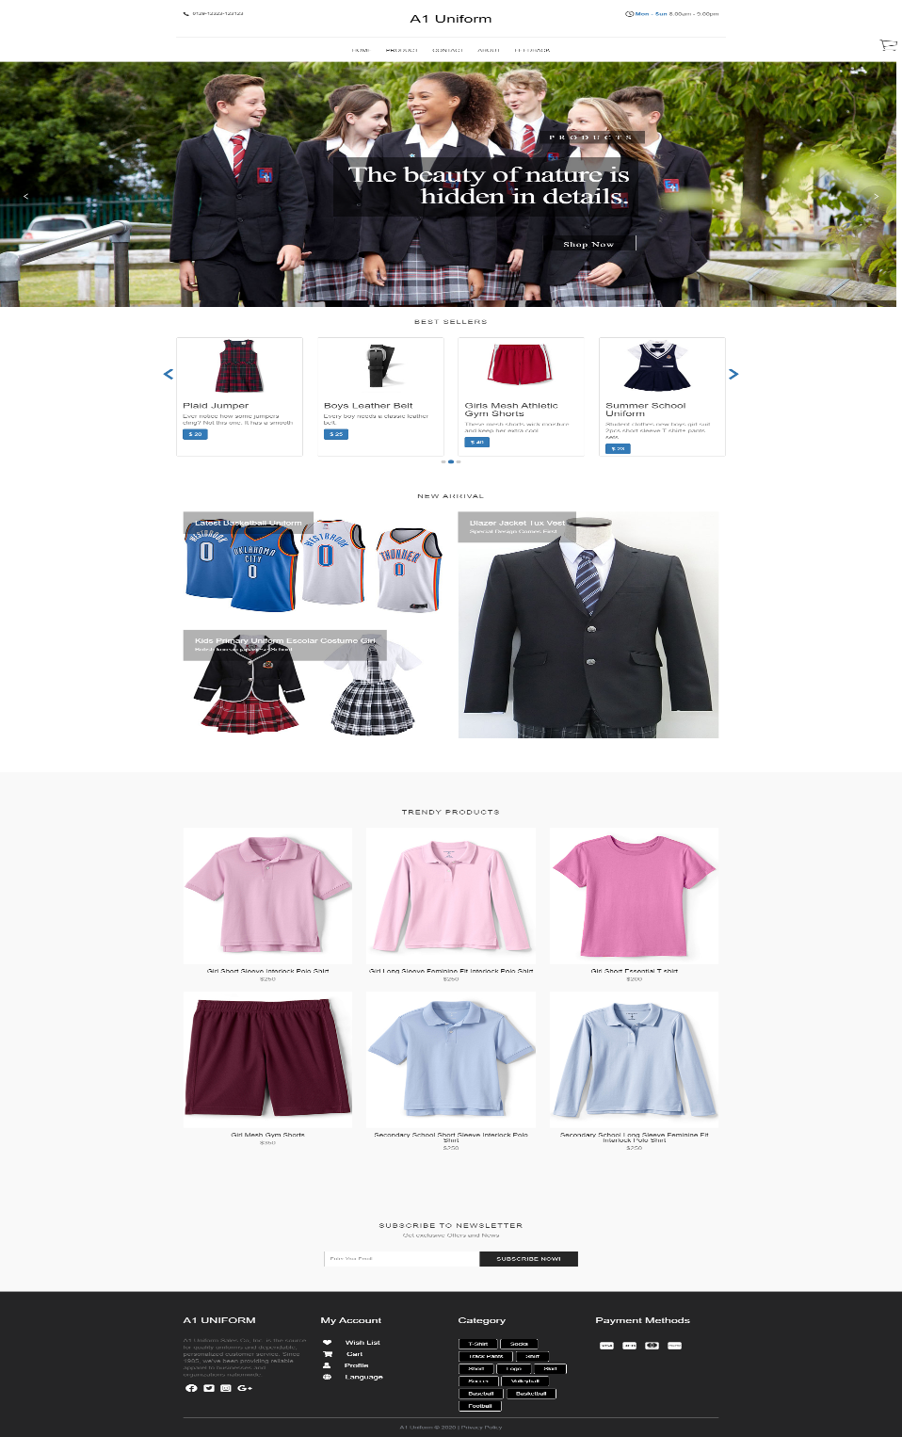

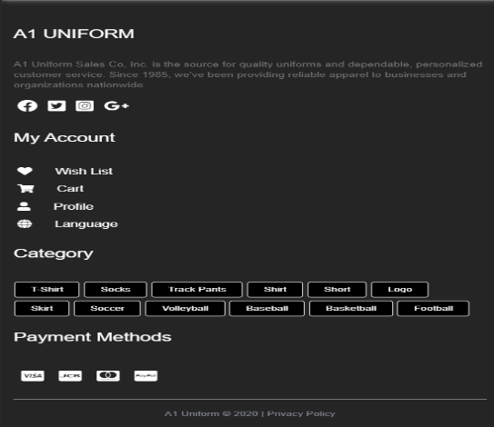

1. **Navigation Bar**

Description of hover effects on navigation bar. When users hover (PC) or click (Smartphone) "PRODUCT" button, it will show all object.

**On pc On Smartphone**

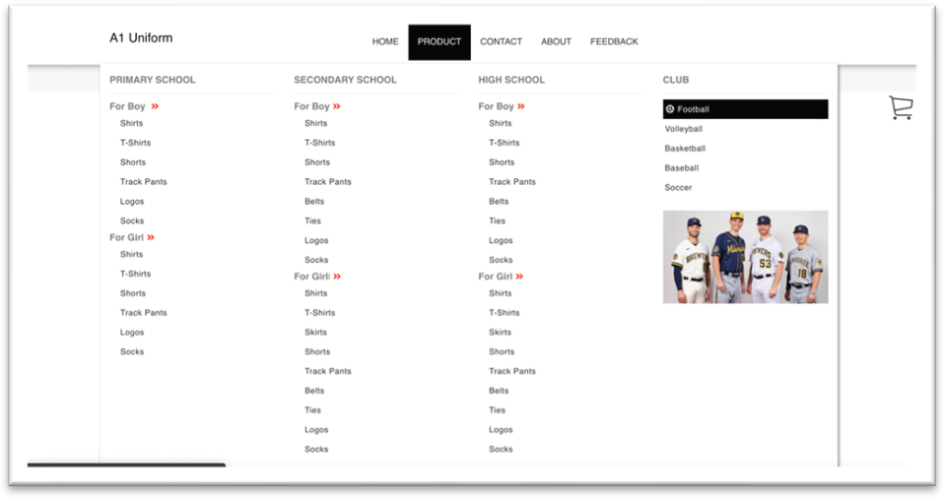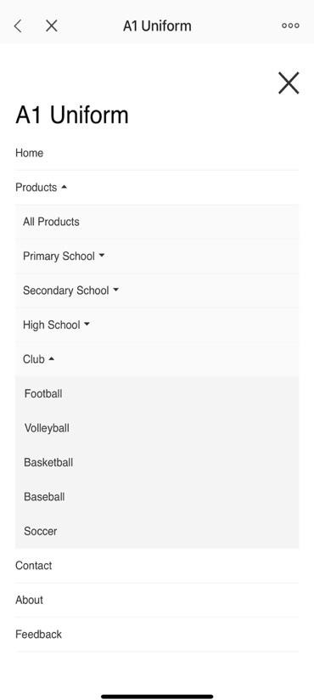

1. **All Products**

When users click on “PRODUCT” button on navigation bar, all products will be shown. Besides, there is a **Categories bar** at the left side for users to find products easily.

**On pc On Smartphone**

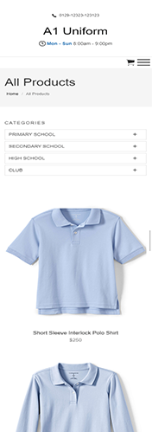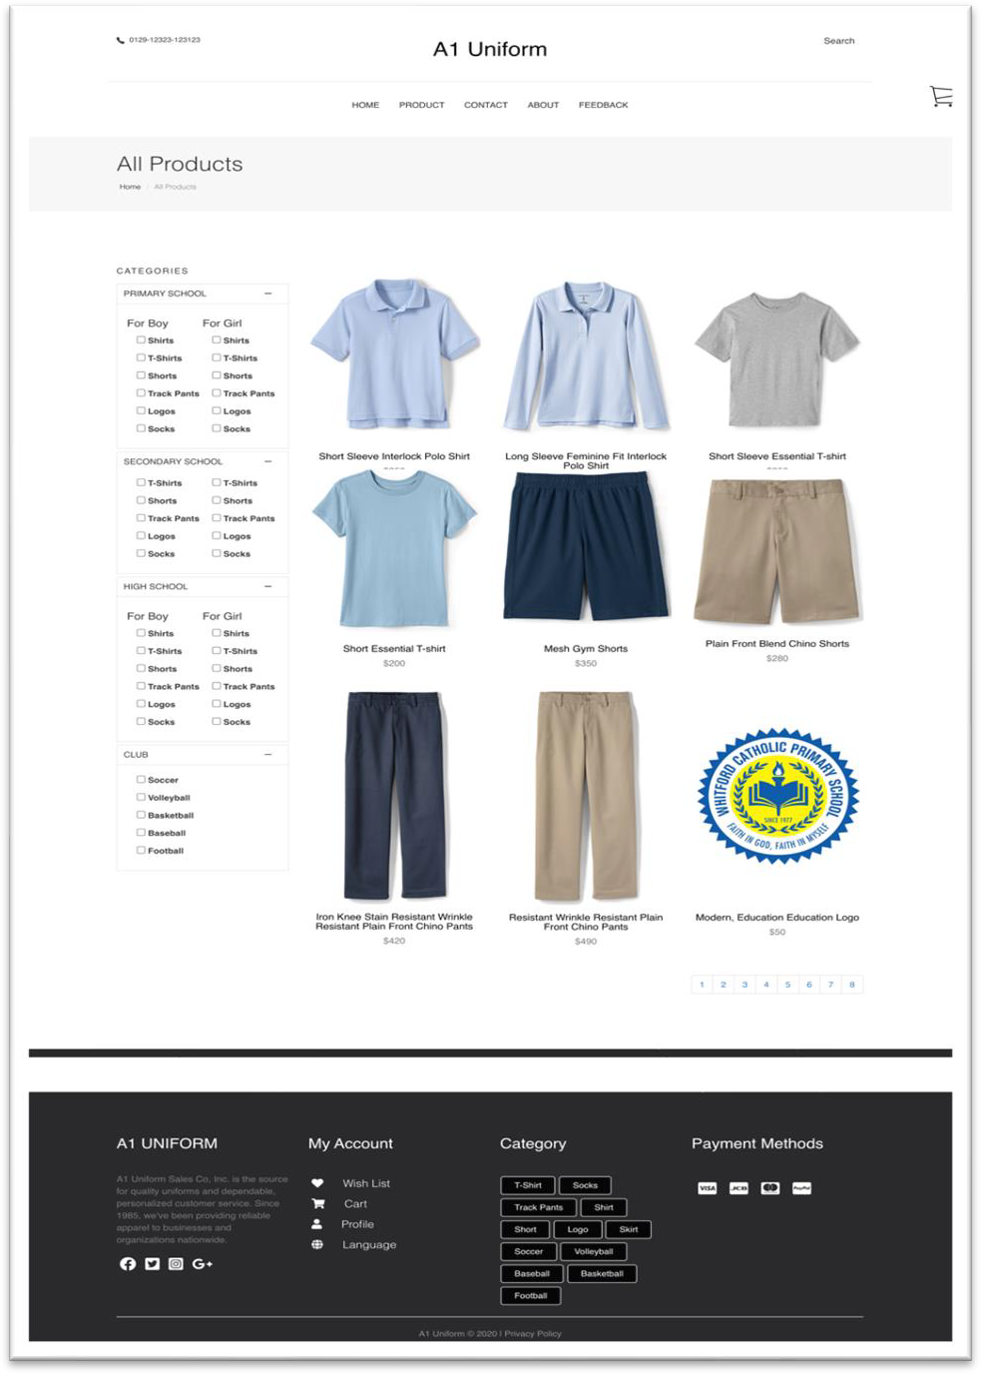

1. **Detail Products**

When users click on any product, the information such as: name, price, material will be displayed. Users maybe buy it when click on the “Add To Cart” button.

**On pc On Smartphone**

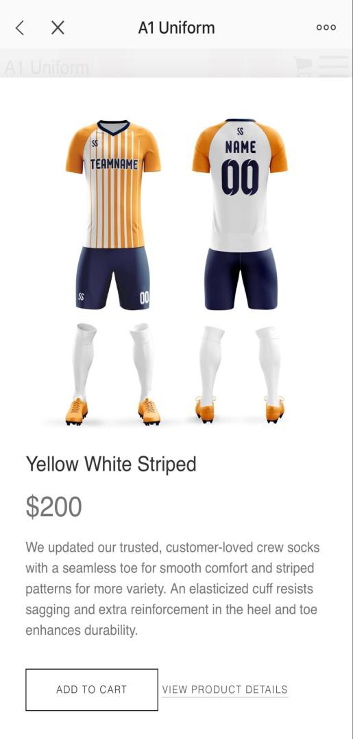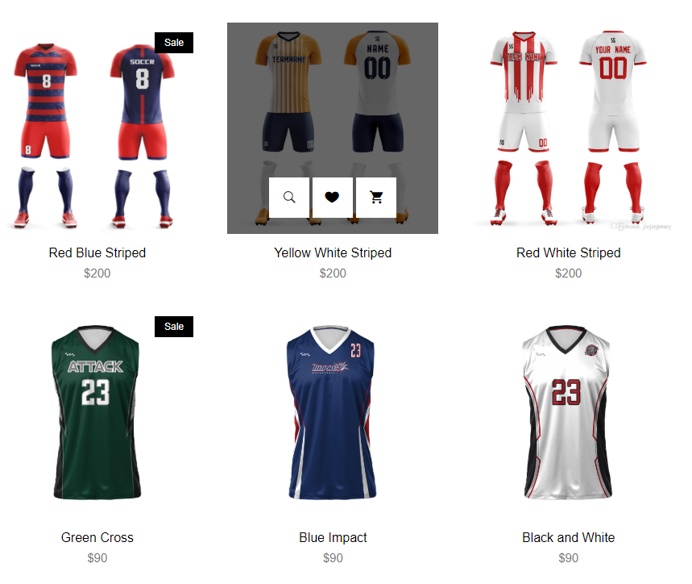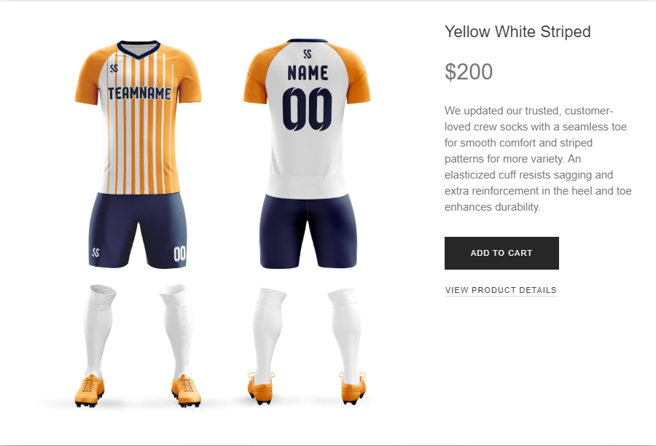

1. **View Cart**

Showing the user’s shopping cart information (product, amount) and total price. Users can checkout when click “CHECKOUT” button.

**On pc On Smartphone**

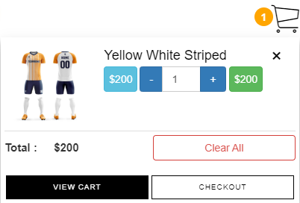

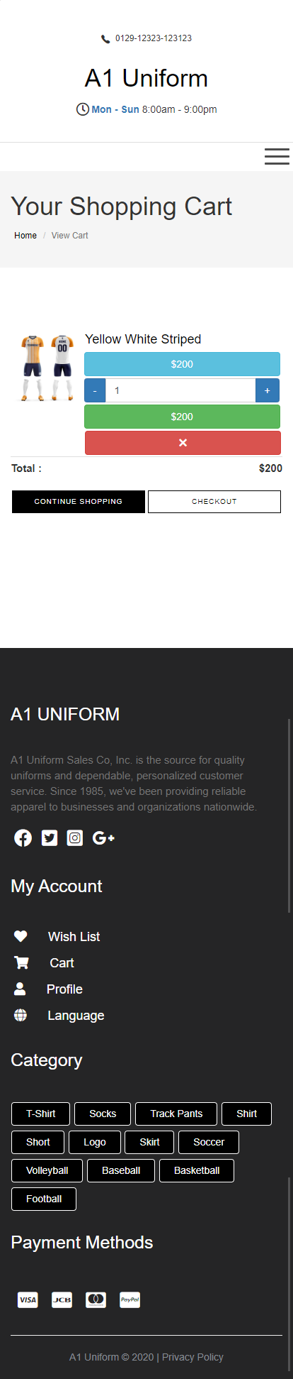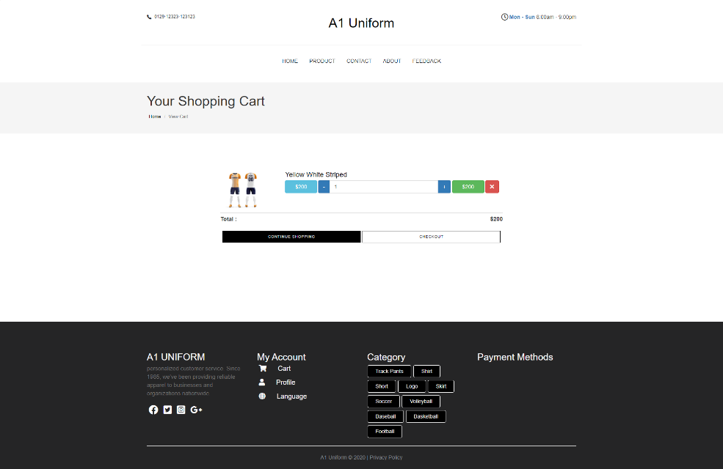

1. **Checkout**

Displaying the Bill Details and Payment Method.

**On pc On Smartphone**

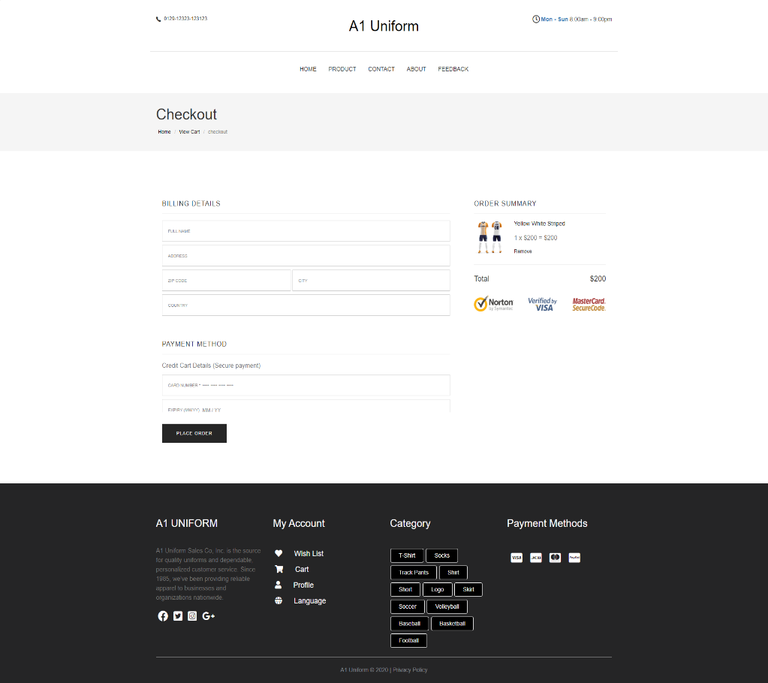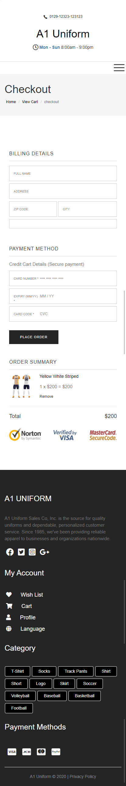

1. **Contact Us**

Display an address, phone number, fax and an email to contact with us. In addition, we have a form which users can fill some information as an email or a message for us. The address was displayed by using GeoLocation API (e.g. Google Maps).

**On pc On Smartphone**

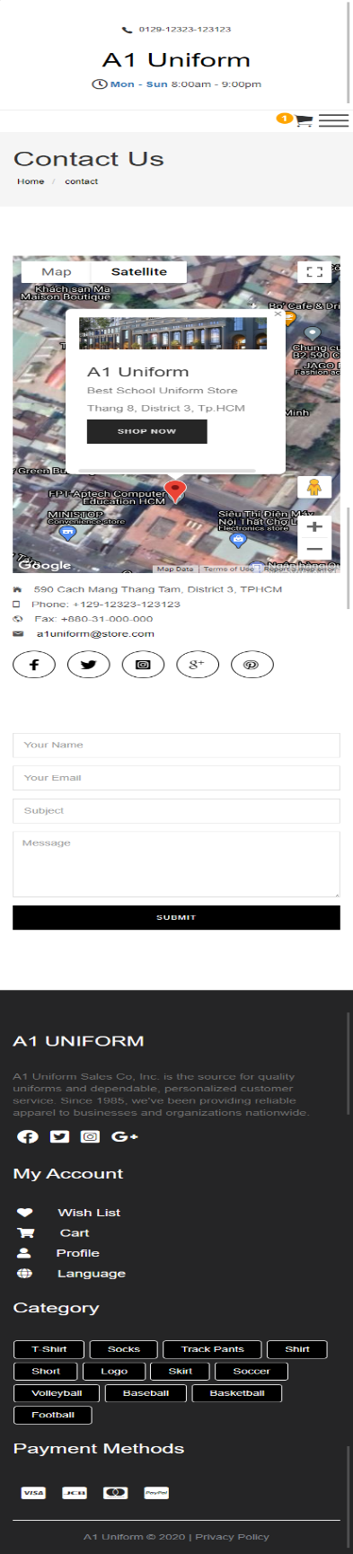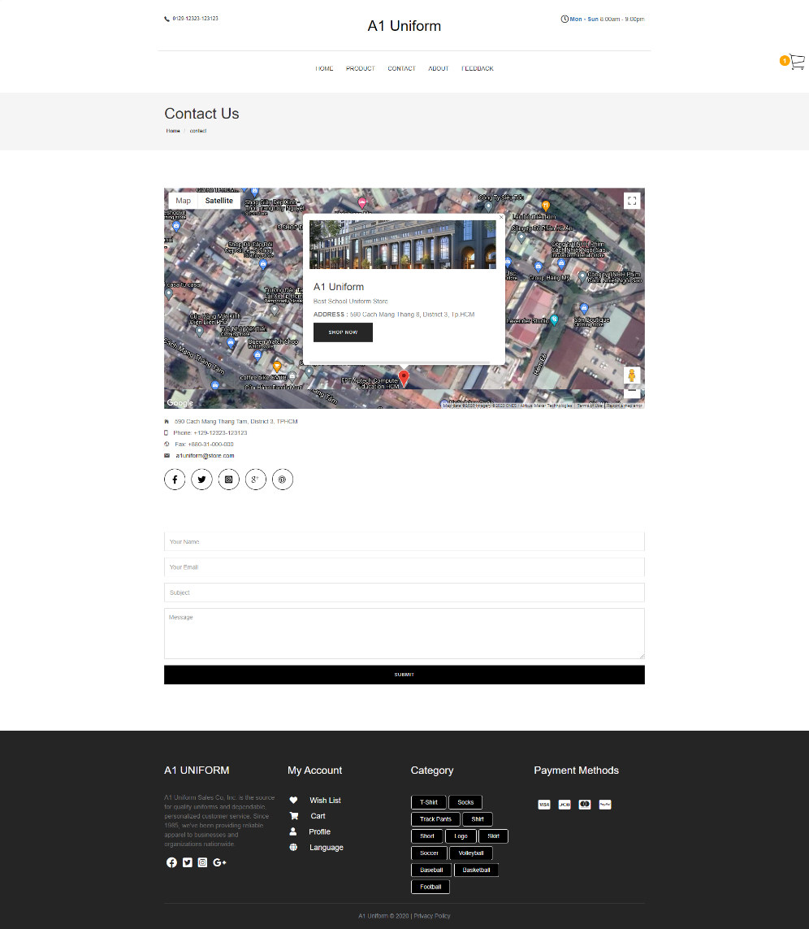

1. **About**

Introduce the main information, history, some factory’s image, 4 members and a short video record a process of project.

**On pc On Smartphone**

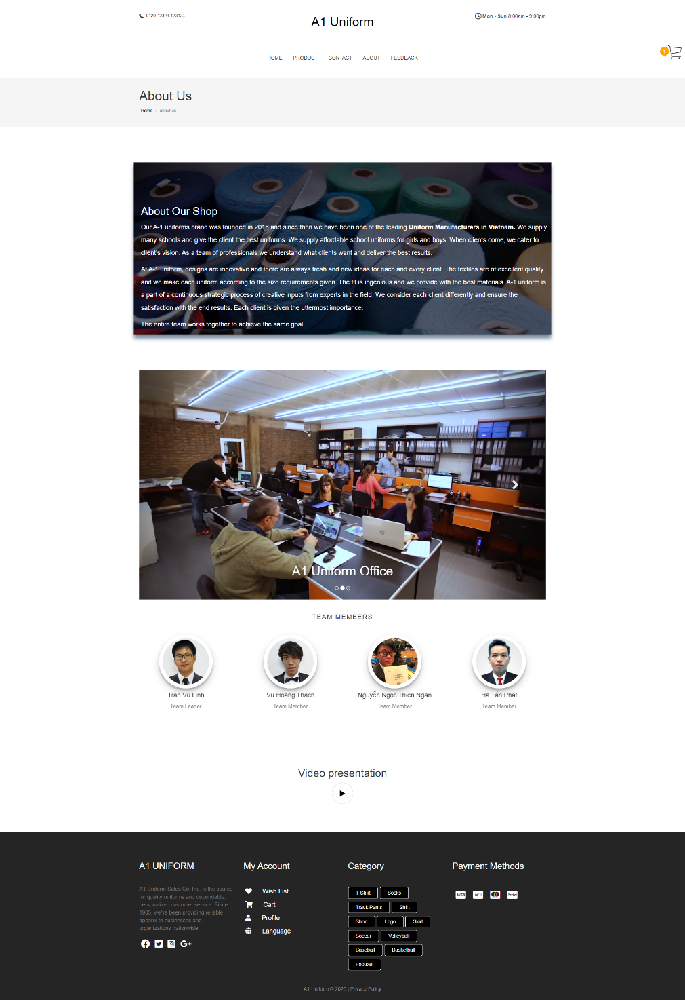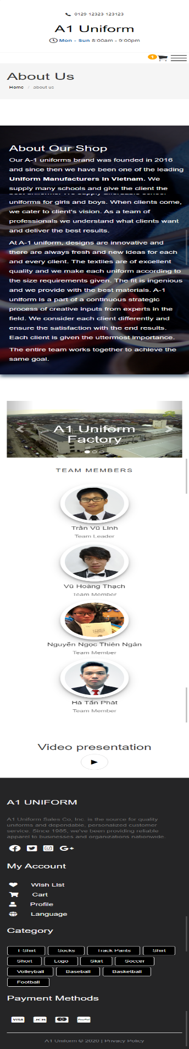

1. **Feedback**

Get the feedback from users.

**On pc On Smartphone**

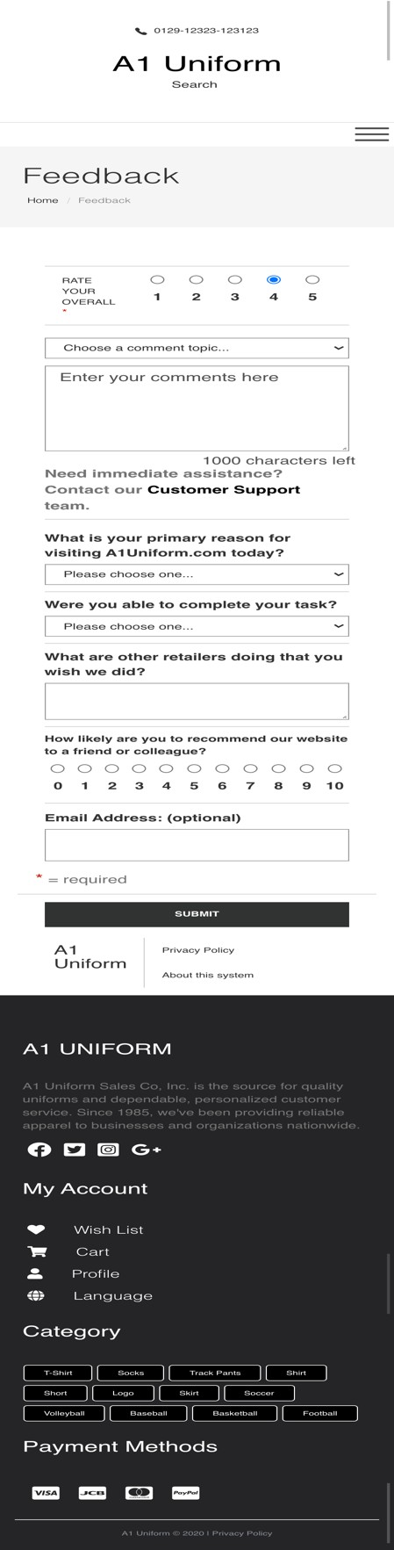

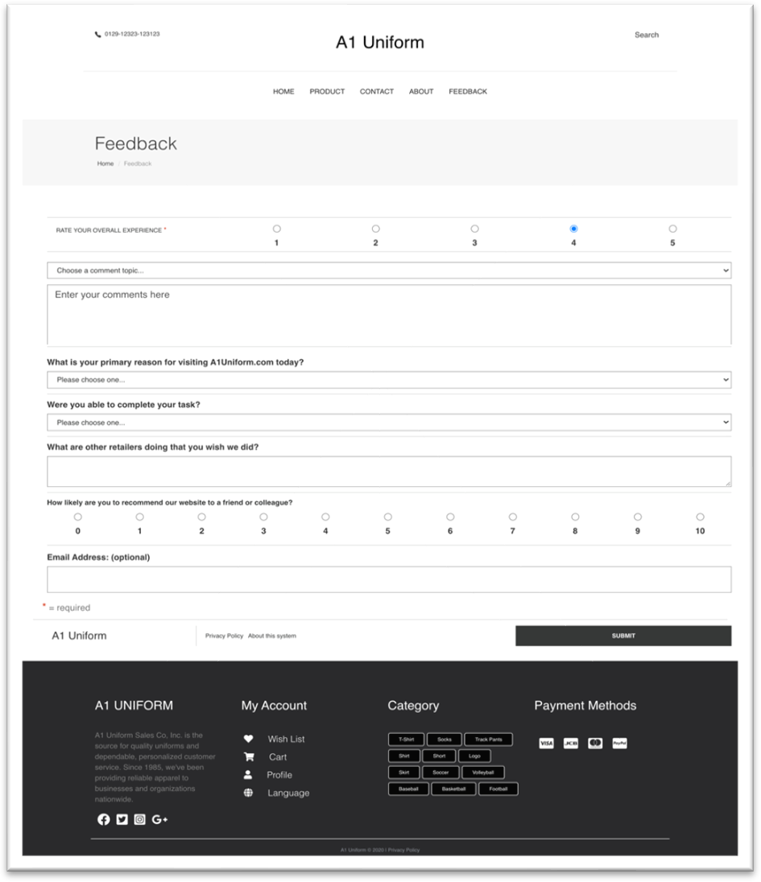

### MODULE DESCRIPTION

This chapter will provide information about module function integratedin the website

1. 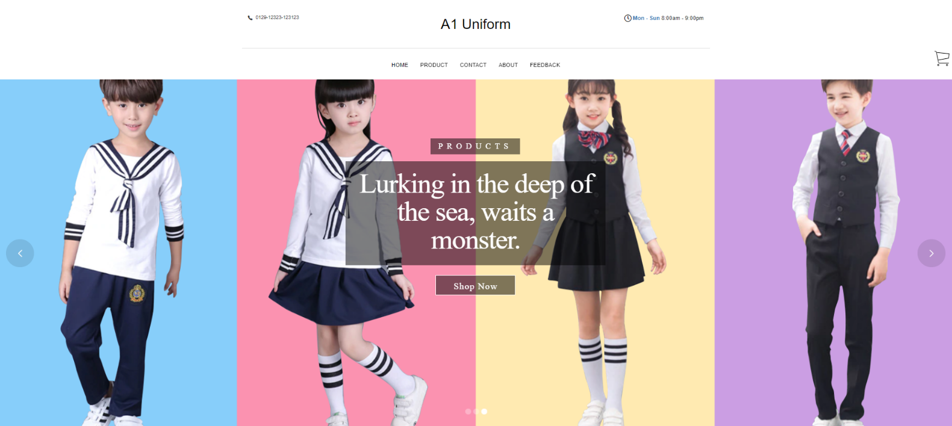**Banner Slider**
2. **Description**

We just use Revolution Slider for slide function. There are tons of great features built into Slider Revolution to make creating custom sliders for your website easy. Here are a few of our favorites.

it has transfer time 4s.

1. 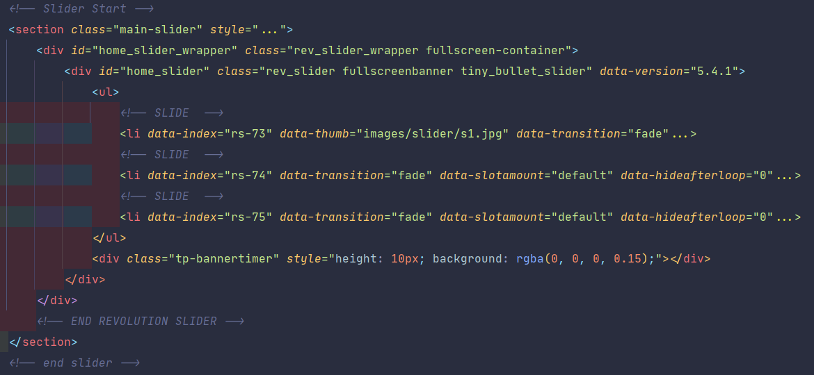**Source Code with Comments**

Declare a div tag with id is home_slider

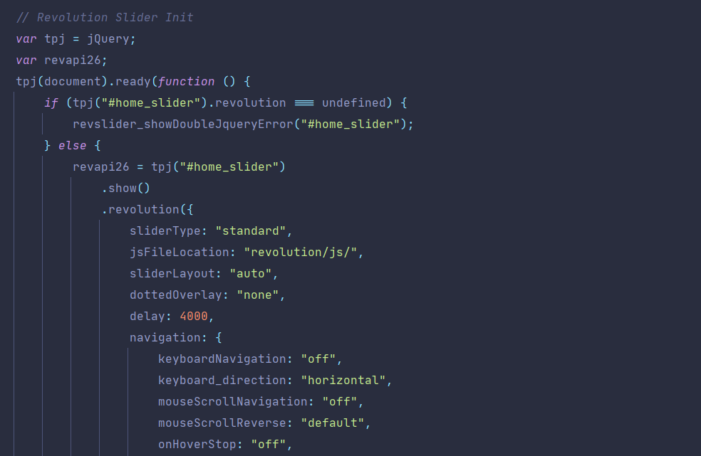

*Use the id selector #home_slider*

1. **Best Sellers Slider**

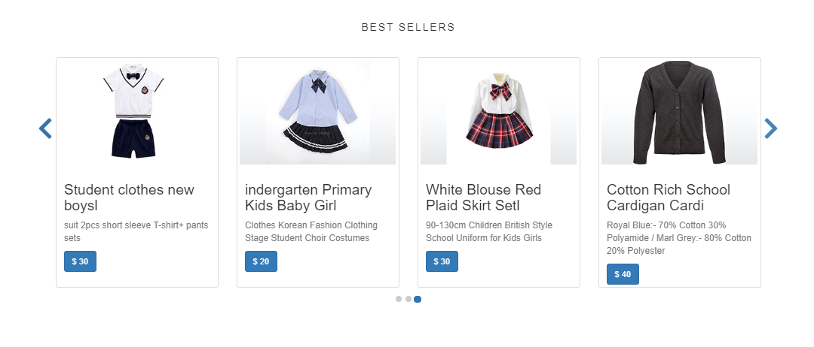

1. **Description**

We just use Bootstrap Carousel and custom CSS, A layer will have 4 products shown. Can control display and purchase directly by clicking the price button.

1. **Source Code with Comments**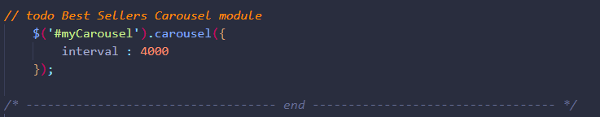

Use the id selector #myCarousel and assign the method carousel

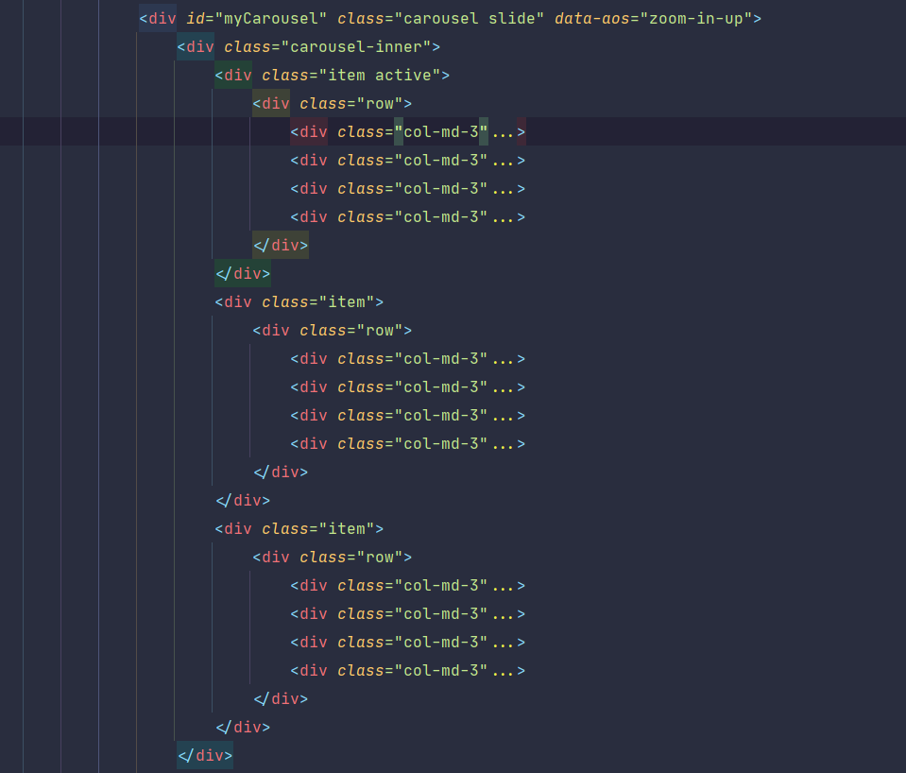

Declare a div tag with id is myCarousel

1. **Cart Module**

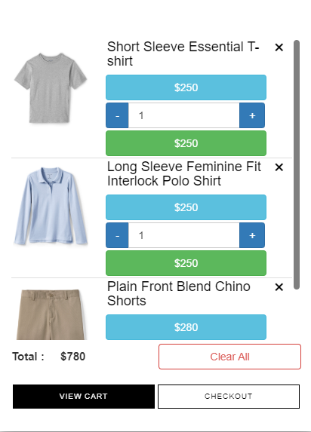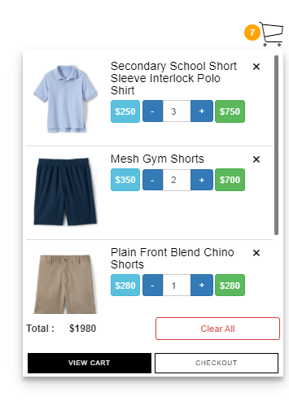

1. **Description**

Cart module is a piece of software that keeps the record of the items a buyer has ‘picked up’ from the online store. Acting as an online store’s catalog, the eCommerce shopping cart enables consumers to select products, review what they selected, make modifications or add extra items if needed, and purchase the products.

1. **Source Code with Comments**

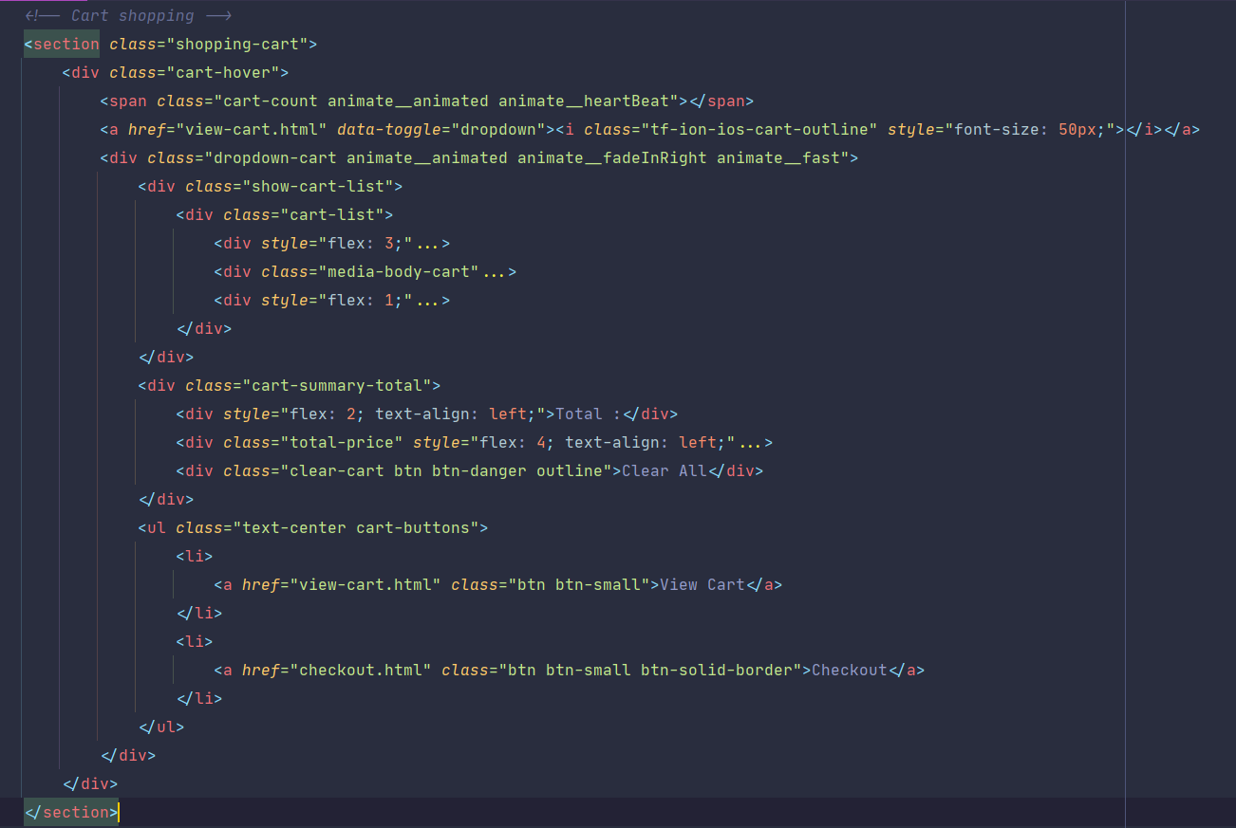

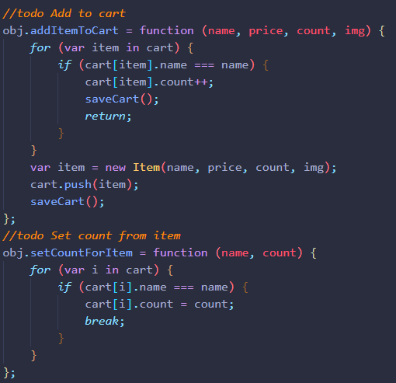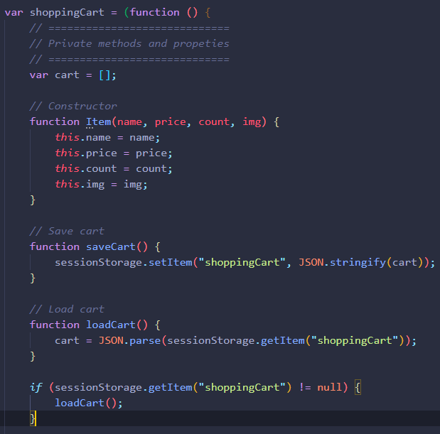Declare a section tag with class is shopping-cart

Some functions of the cart module: additemToCart, v.v

1. 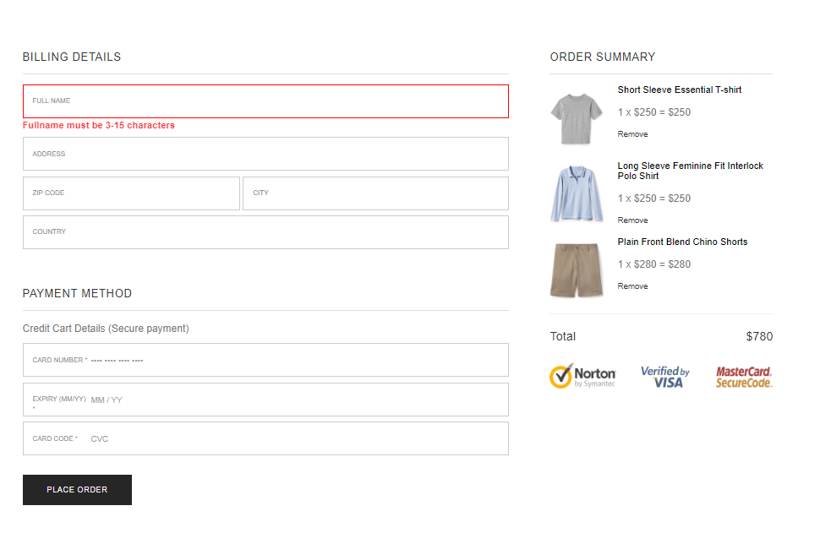**Checkout info validation module**
2. **Description**

This is called form validation. When you enter data, the browser and / or the web server will check to see that the data is in the correct format and within the constraints set by the application. Validation done in the browser is called client-side validation, while validation done on the server is called server-side validation.

If the information is correctly formatted, the application allows the data to be submitted to the server and (usually) saved in a database; if the information isn't correctly formatted, it gives the user an error message explaining what needs to be corrected, and lets them try again.

1. **Source Code with Comments**

Declare form tag with 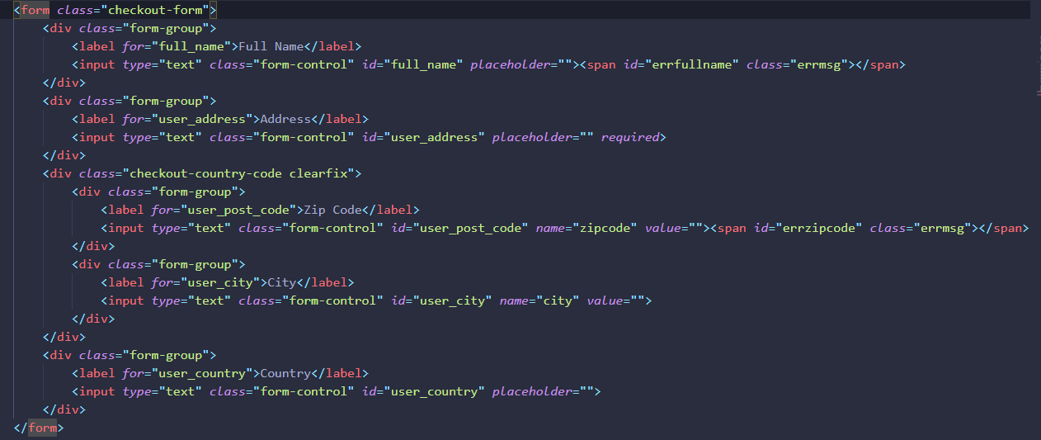class checkout-form

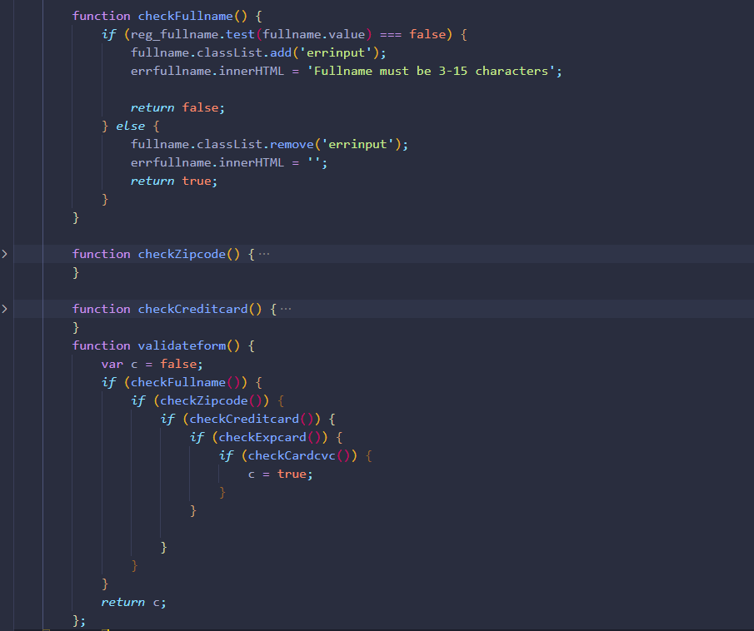

Some validation functions

1. 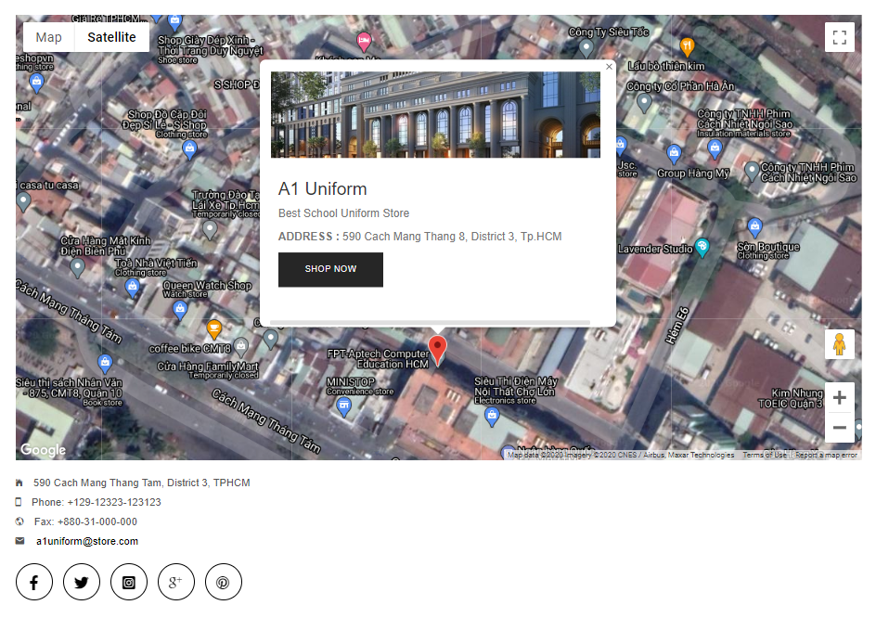**Map direction module**
2. **Description**  
   Displays a map of the store's location, using google geolocation api. The Geolocation API returns a location and accuracy radius based on information about cell towers and WiFi nodes that the mobile client can detect.
3. **Source Code with Comments**

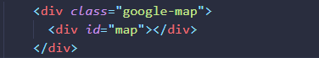

*declare div id tag is map*

*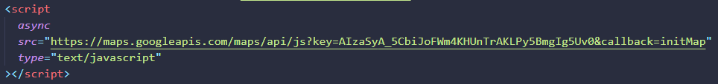include Geolocation API*

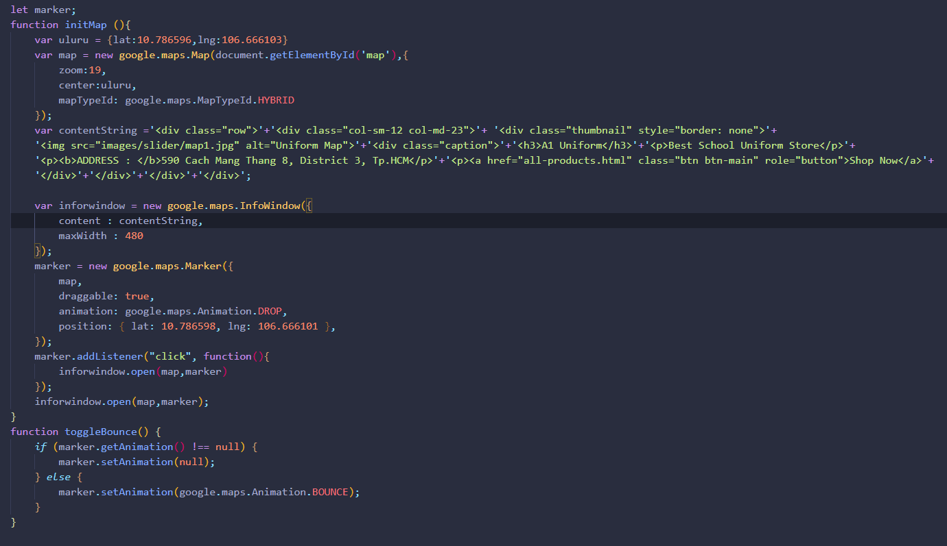

*declare function initMap*

1. 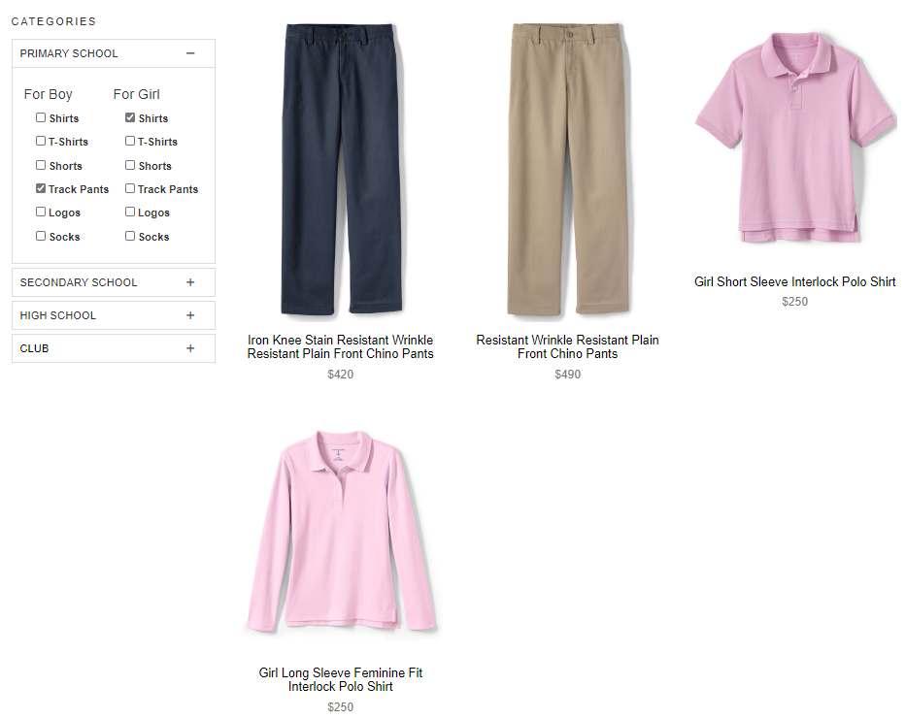**Sort and filter module**
2. **Description**

Supporting users to find products in each category, users can quickly find out which products to buy.

1. **Source Code with Comments**

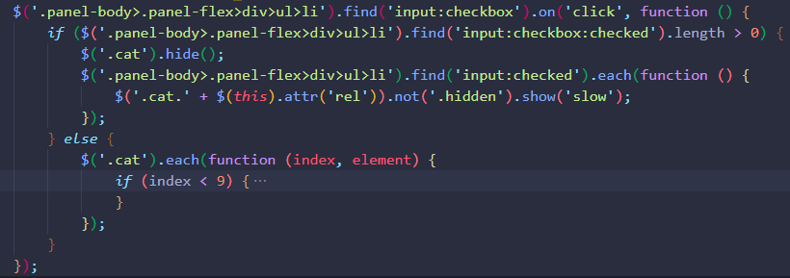Use the ul li tag to display the checkbox

Use the find method to search for checked checkboxes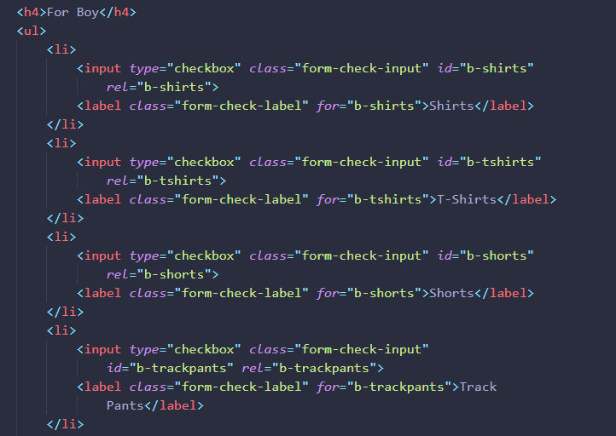

### TASK SHEET REVIEW 3

|  |  |  |  |  |  |  |  |
| --- | --- | --- | --- | --- | --- | --- | --- |
| **Project Ref. No.:**  **eP/Advertisement Portal Management System/01** | | **Project Title:** | **Activity Plan Prepared By:** | **Date of Preparation of Activity Plan:** | | | |
| **Sr.**  **No.** | **Task** | **Actual Start Date** | **Actual Days** | **Team Mate Names** | **Status** |
| 1 | Template | A1 Uniforms | Linh | 11/8/2020 | 1 | 4  members | Completed |
| 2 | Navigation Bar | 13/8/2020 | 1 | Ngan | Completed |
| 3 | Homepage | 13/8/2020 | 1 | Linh | Completed |
| 4 | Contact Us | 13/8/2020 | 1 | Thach | Completed |
| 5 | About | 13/8/2020 | 1 | Phat | Completed |
| 6 | Feedback | 14/8/2020 | 1 | Thach | Completed |
| 7 | Map | 13/8/2020 | 1 | Thach | Completed |
| 8 | Products | 15/8/2020 | 1 | Linh, Ngan, Phat | Completed |
| 9 | Footer | 14/8/2020 | 1 | Ngan | Completed |
| 10 | Gathering information and images | 13/8/2020 | 1 | 4  members | Completed |
| 11 | Add to Cart, Checkout | 15/8/2020 | 1 | Thach, Linh | Completed |
| 12 | Module Description | 20/8/2020 | 2 | Linh | Completed |
|  | | | | | | | |
| **Date:** | | | | | | | |
| Signature of Instructor:  **Mr. Nguyen Ngo Phuoc** | | | | Signature of Team Leader:  **Tran Vu Linh** | | | |